**Newcastle Civic Centre**

**Do you need this in an alternative language or format? Please email:** [**propertylicensing@newcastle.gov.uk**](mailto:propertylicensing@newcastle.gov.uk)

**Date:** **Wednesday 10 September 2025**

**Time:** 5–7pm

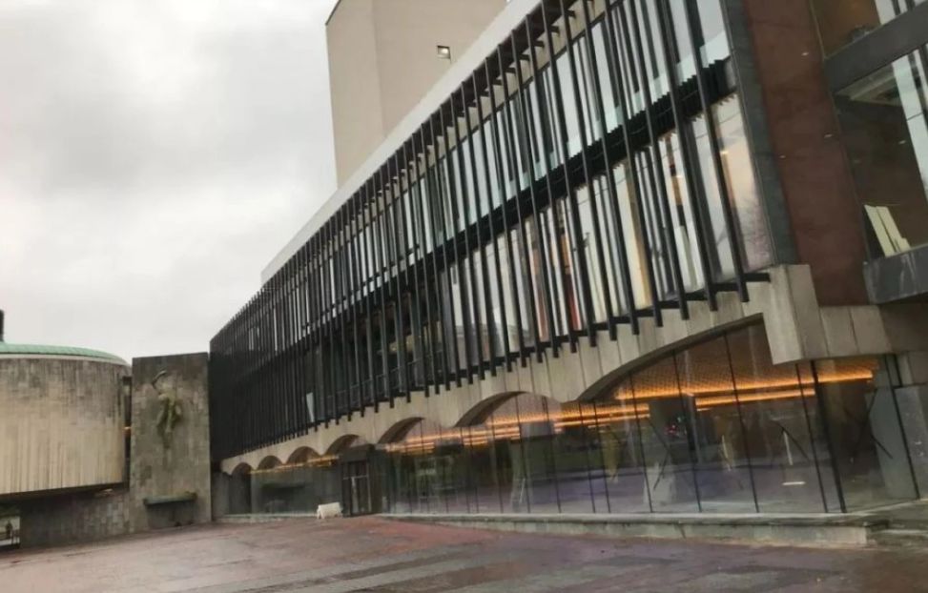**Location:** Civic Centre, Barras Bridge, Newcastle upon Tyne, NE1 8QH

**Reception**

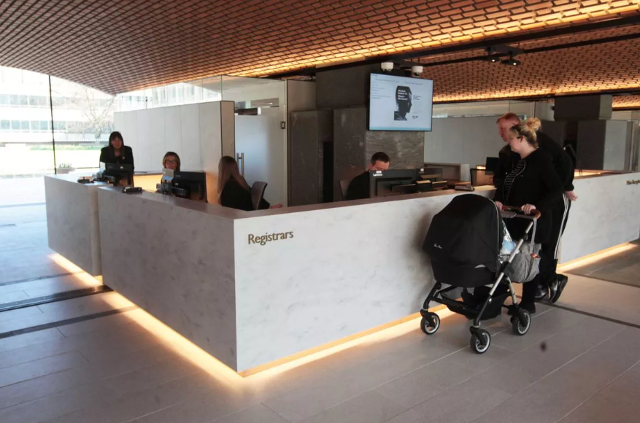

**Venue Car Park**

* Access to this car park is off Sandyford Road.
* This is a pay-and-display car park, free to blue badge holders.
* The car park is located at the rear of the building.
* The car park type is open air/surface.
* There is / are 5 designated parking bay(s) within the car park.
* The route from the car park to the entrance is accessible to a wheelchair user with assistance. Assistance may be required because there is / are dropped kerbs.

**The Council Chamber**

* There are designated spaces for wheelchair users.
* Designated seating is located the rear rows.
* Wheelchairs are left with the patron.
* There is a hearing assistance system. The hearing system is a fixed loop.
* Assistance dogs are allowed in the auditorium.
* There are 7 clearly marked shallow steps leading down to further seating. There are further steps at each side although no hand rails are available.

**Why is this session happening?**

The Property Licensing team have set up events to allow members of the public to have their say in the consultation on a proposed selective licensing scheme. The licensing scheme means that all private landlords in the area covered by the scheme must have a licence from the Council to rent out property. The aims are:

1) to improve the private rented market, because properties must be of a decent standard before landlords can rent them out, and

2) to give tenants more confidence that houses and flats in the area covered by the scheme will be healthy and safe to live in. There are seven 'selective licensing' areas already operating in Newcastle.

We are consulting on our proposals which could see the renewal of selective **licensing schemes** in the following areas for another five years.

* Byker Old Town
* Allendale Road
* Greater High Cross

All private rented properties within a selective licensing area require a licence unless they are otherwise exempt.

To learn more about the licensing scheme visit:   
<https://new.newcastle.gov.uk/property-licensing-schemes-newcastle>

**What will happen in the session?**

The event will have a presentation between 5-5.30pm this will be followed by a Question-and-Answer session. For more information go to: [Newcastle Selective Property Licensing in 2026 Byker, Allendale Road and Greater High Cross](https://forms.office.com/Pages/ResponsePage.aspx?id=wLSfsgQNn0q0YsEpSx4bRwM_WewsuG1EkyEh3CVRL6pUMFA2UVdBODVGVUZETkI2RjAzSFRHR0lTTS4u)

**How do I get to Newcastle Civic Centre?**

Follow this link to see the West End library on Google Maps:

[Newcastle Civic Centre - Google Maps](https://www.google.com/maps/place/Newcastle+Civic+Centre/@54.9786658,-1.6126949,595m/data=!3m1!1e3!4m7!3m6!1s0x487e70cedb33f76f:0x2cb306077ddbef64!4b1!8m2!3d54.9786627!4d-1.61012!16s%2Fg%2F1yfdr_832?entry=ttu&g_ep=EgoyMDI1MDcyNy4wIKXMDSoASAFQAw%3D%3D)

**Public Transport**

There is a bus stop within 150m (164yds) of the venue. The nearest National Rail station is Newcastle Central. The nearest Metro Station is Haymarket.

**Where are the toilets?**

It is 28m (30yd 1ft) from the designated seating area to the nearest accessible toilet.

**If I have any questions before the event, who can I talk to?**

If you have any questions ahead of the event, contact our team on: [**propertylicensing@newcastle.gov.uk**](mailto:propertylicensing@newcastle.gov.uk) 

**If I have any questions at the event, who can I talk to?**

At the event we will have Officers who will introduce themselves to you at the door. You can ask them any questions about the event.

**Thank you!**